- Report of Findings -

Personal Report of Findings for Date .
Your Constitution is Weak Liver/Gall Bladder Strong Lung/Large Intestine
Nutrition Recommendation for 1 week (Detail list will provide after final diagnosis)
Beneficial Regimen | Regimen to avoid
Leafy Greens: Napa, cabbage, lettuce, spinach, watercress, kale, chicory, mugwort, crown daisy, eggplant, broccoli, celery, bean sprout, curled mallow, cucumber, parsley……  Most of ocean fish, seafood, shellfish  Banana, berries, kiwi, persimmon, cherry, plum, green grape, pineapple, peach, oriental melon, pomegranate  Rice, barley, buckwheat, red bean, mung bean  Aloe vera, omega3, cacao, dark chocolate, egg white  Activity: Swimming, walking, stretching, yoga, aerobic exercise(with less perspiration) | All kinds of meat and dairy products, eel(unagi), catfish  All kinds of flour food, nuts, seeds, mushroom  Sesame seed oil, perilla seed oil, soybean oil, cooking oil  Too much of Root vegetable and Spices  Apple, orange, pear, melon, watermelon  Sweet rice, millet, corn, pearl barley, soy bean  Most of western medicine, ginsheng, date, honey, calcium supplement, iron supplement  Caffeine, sports drink  Activity: Sweating(=sauna), tanning

Your health Concerns .
What we found .
What do you expect from first visit and constitution regimen
Everyone’s response is vary from their condition, but your health concerns must be improve from right diagnosis. Your response is very important to decide your final constitution. Please listen your body carefully and bring us your result. We expect better digestion, bowel movement and higher energy level from nutrition recommendation. .
REMARK (태양인)
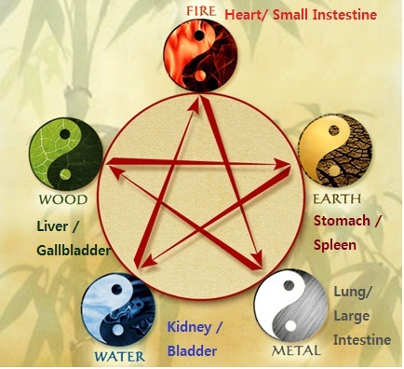

©Suwaneeacupuncture ●770 681 8888 ● www.suwaneeacupuncture.com

